





Better Translation Technology

XTM Connect for WordPress

Documentation for XTM Connect for WordPress.

Published by XTM International Ltd.

© Copyright XTM International Ltd. All rights reserved. No part of this publication may be reproduced or transmitted in any form or by any means, including photocopying, without prior written consent of XTM International Ltd.

**Updated: May 2021**



XTM-International Ltd, PO Box 2167, Gerrards Cross, SL9 8XF, UK

Tel.: +44 (0)1753 480479 email: sales@xtm-intl.com [https://www.xtm.cloud](http://www.xtm-intl.com/)

# Table of contents

**1.** **Table of contents 3**

**2.** **Introduction 4**

**3.** **Requirements and installation 5**

Requirements 5

Supported versions of The WordPress Multilingual Plugin (WPML) 5

Installation 5

**4.** **WordPress Multilingual Plugin (WPML) 6**

*Configuration 6*

1. WPML Setup: Content language 6

2. WPML Setup: Translation languages 7

3. WPML Setup: Language switcher 8

4. WPML Setup: Registration 9

*Overview 10*

Languages 10

Translation Management 11

String Translation 17

**5.** **XTM plugin 20**

*XTM Settings – Configuration 20*

Language mappings 21

Default configuration 21

*WPML Job list 22*

*XTM Project list 22*

# Introduction

XTM Connect for WordPress is an auxiliary application for both XTM Cloud and XTM Suite. It connects directly to your WordPress website, automating the process of sending new or altered content to XTM and creating translation projects. When the project workflow is complete; it returns translated content to the website. XTM Connect for WordPress has several advantages, reducing the number of manual tasks, thereby decreasing costs, turnaround times, and human errors.

Use of the application is provided under a separate software license and is not included in the standard XTM license or subscription agreement.

Contact the XTM Sales at [sales@xtm-intl.com](mailto:sales@xtm-intl.com) to learn more about XTM Connect for WordPress and request a quote. Upon purchase, XTM will enable the API connection for you.

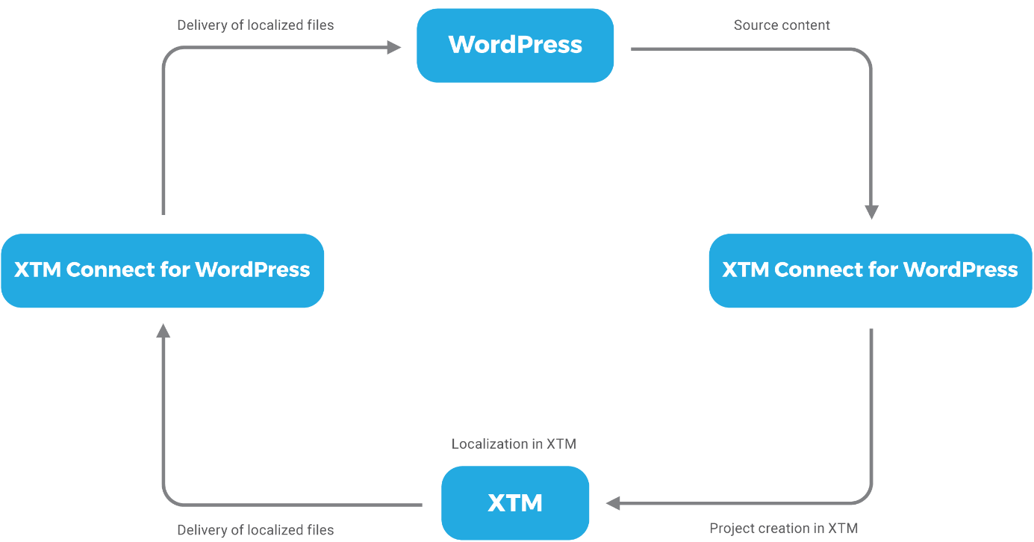

*XTM Connect for WordPress workflow diagram*

# Requirements and installation

### Requirements

XTM Connect for WordPress is installed as an additional plugin to WordPress and requires the WordPress Multilingual Plugin (WPML) to be installed and enabled on the WordPress website.

If you do not have WPML installed on your instance of WordPress, the module is available for purchase and download from <https://wpml.org/>.

Please ensure you have the PHP SOAP extension enabled in your server. For further information please go to [SOAP setup documentation](http://php.net/manual/en/soap.setup.php).

You will also need your XTM API account details. For more information, please contact XTM support at [support@xtm-intl.com](mailto:support@xtm-intl.com).

### Supported versions of The WordPress Multilingual Plugin (WPML)

During the update of The WordPress Multilingual Plugin (WPML) from version 3.9.4 to versions 4.0.0 or higher several structural changes took place. For this reason, a distinction has been made into XTM Connect for WordPress for WPML versions 3.X.X and for versions 4.0.0 and higher.

The last tested and fully supported versions of WPML are 3.9.4 and 4.0.7.

### Installation

The WordPress Multilingual Plugin (WPML) and XTM WMPL Connector plugins must be installed and activated on the WordPress server.

1. Purchase and download The WordPress Multilingual Plugins for WordPress from <https://wpml.org/>. The WPML plugin modules include:
   * WPML Multilingual CMS
   * WPML String Translation
   * WPML Translation Management
   * WPML Sticky Links
   * WPML CMS Nav
2. Install and activate the WordPress Multilingual Plugin (WPML) modules. Each WPML plugin module has to be contained in a separate zip archive and only one can be installed at a time. Open the WordPress menu, go to the Plugins tab, and click the Add New button. Click the Upload Plugin button. Select a WPML plugin module to install, then click the Install Now button. Install all of the WPML plugin modules, as listed in point 1. When all WPML plugin modules are installed, activate them on the plugins tab.
3. Install and activate the XTM WMPL Connector plugin. Open the WordPress menu, go to the Plugins tab, and click the Add New button. Click the Upload Plugin button. Select a the XTM WMPL Connector plugin and click the Install Now button. The XTM WMPL Connector plugin consists of only one zip archive.

Alternatively, users with access privileges to the ftp where WordPress with the website is installed can extract the zip archives of all WPML and XTM plugin on their local drive, upload them to the servers ../wp-content/plugins directory, and activate the plugin modules on the Plugins page.

# WordPress Multilingual Plugin (WPML)

## Configuration

The WordPress Multilingual Plugin must be configured before content can be translated. Open the WordPress menu, go to the Plugins tab and click the Configure WPML button, then follow the steps below.

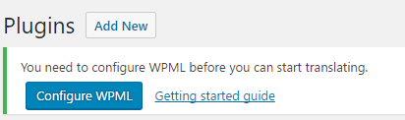

*WPML plugin configuration*

### 1. WPML Setup: Content language

Select your original content language from the dropdown list.

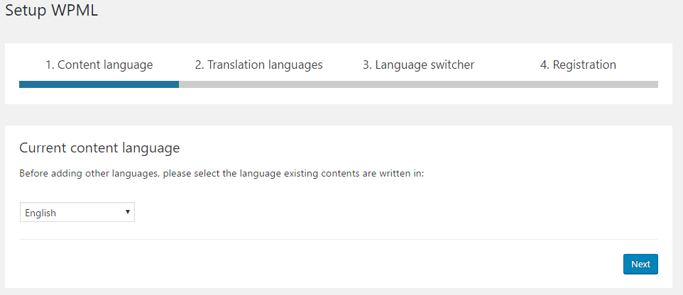

*Selecting the original content language*

### 2. WPML Setup: Translation languages

Choose the languages in which you want to publish your content.

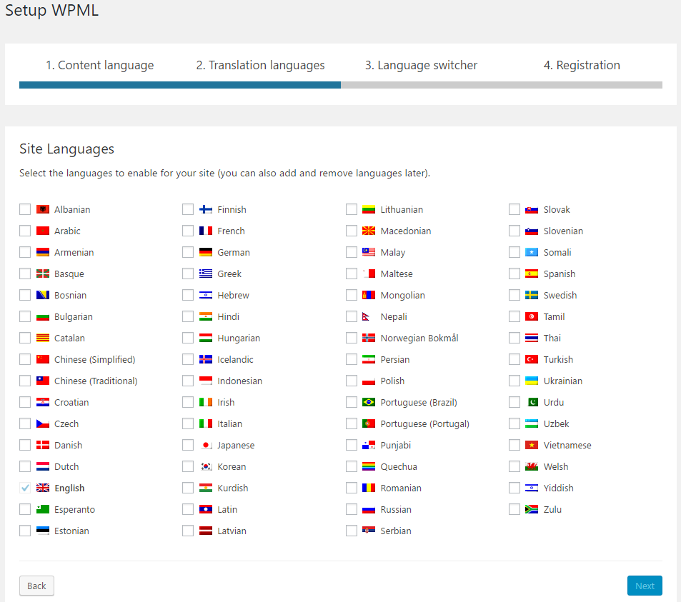

*Selecting translation languages*

### 3. WPML Setup: Language switcher

Configure the language switcher.

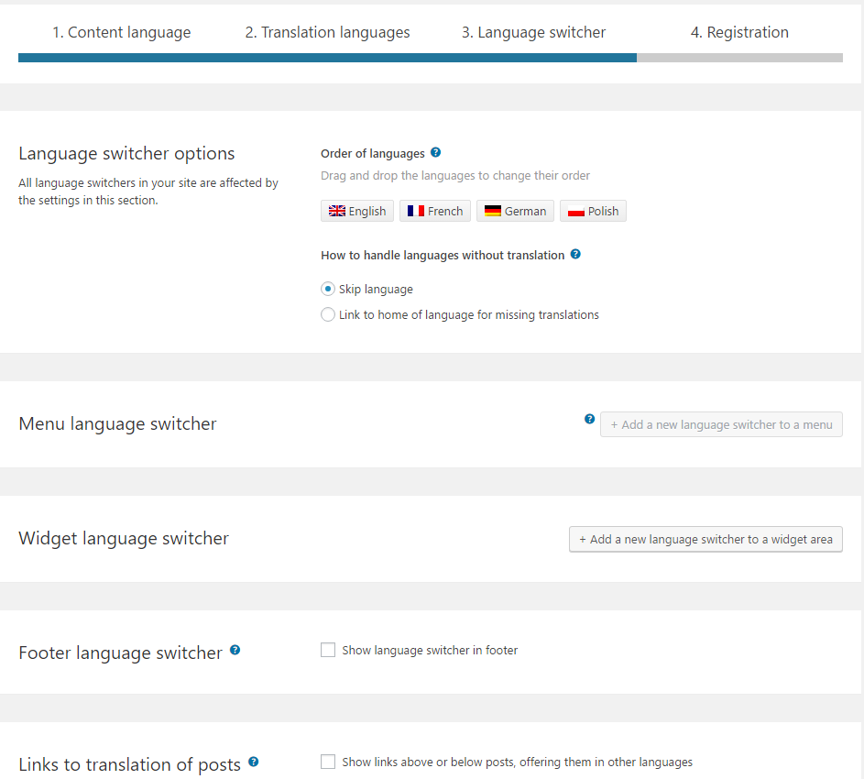

*WPML language switcher configuration*

### 4. WPML Setup: Registration

Registration is required to receive automatic updates of the WPML plugin but this can be skipped if preferred.

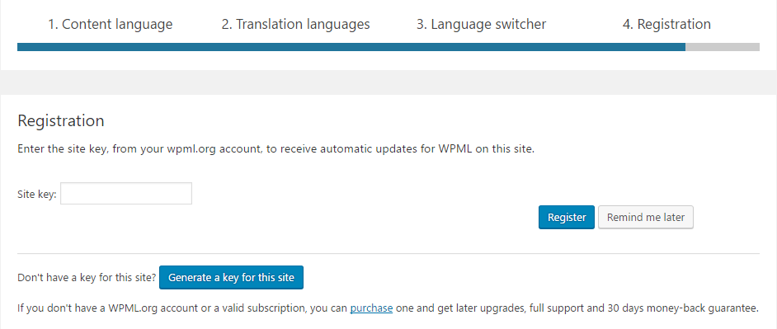

*WPML Registration*

Further information about the configuration of the WPML plugin is available in the WPML Getting Started guide: <https://wpml.org/documentation/getting-started-guide/language-setup/>.

Any settings configured during the WPML setup can be updated later in the WPML tab of WordPress.

## Overview

The WordPress Multilingual plugin provides a number of new tabs to the WordPress menu, but only the following are essential for translation in XTM: Languages, Translation Management and String Translation.

### Languages

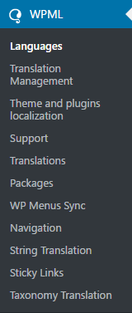

*Sections available in the WPML plugin*

The Languages section contains various language settings including those configured during the WPML setup. It is crucial to make sure Site Languages are set, and to check whether the Language switcher is configured correctly.

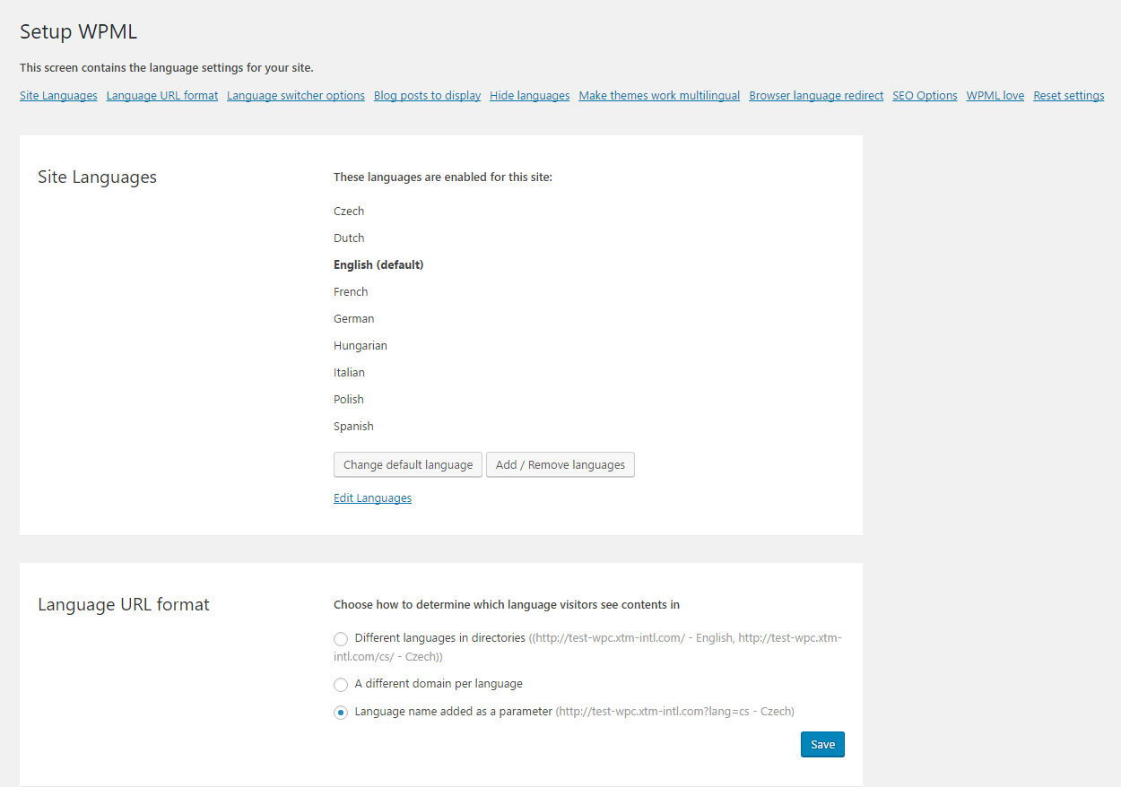

*The Languages section of the WPML plugin*

### Translation Management

The Translation Management section of the WPML plugin is divided into Translation Dashboard, Translators, Translation Basket (displayed only when a job has been added to the basket), Translation Jobs, Multilingual Content Setup and Translation Notifications.

#### Translation Dashboard

The Translation Dashboard lists all page and blog items that can be translated on your website. The list provides information when an item was created, whether it is a page or a post and the publishing and translation status for specific languages. Translatable items can be filtered.

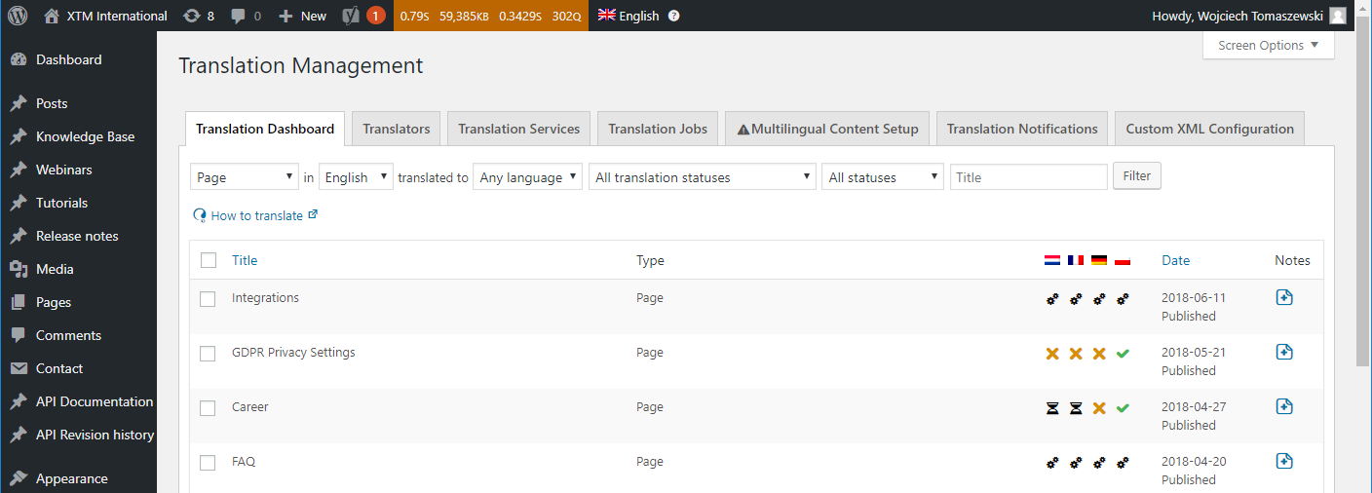

*A list of translatable pages and blogs*

Translation statuses:

|  |  |  |
| --- | --- | --- |
|  | Not translated | The item is not sent for translation. |
|  | Waiting for translator | The item is waiting for a translator to claim it or the translation is in progress. |
|  | In progress | A project has been created in XTM and the item is in the process of translation. |
|  | Complete | The item has been translated and returned. |
|  | Needs update | The item has been updated and requires another round of translation. |

Also, a list of languages set for the website is displayed below the content items. For each language it is possible to Translate, Duplicate content or Do nothing.

* Translate: content is translated into the specified language.
* Duplicate content: content is not translated. Instead, source text is copied to posts displayed for specified languages. Posts and pages with the duplicated content are then related to the source text. When the source text changes in the original post, texts in posts for the languages with duplicated content are automatically updated. Any changes introduced directly to posts with duplicated content will not be saved.
* Do nothing: no action will be performed for the specified languages.

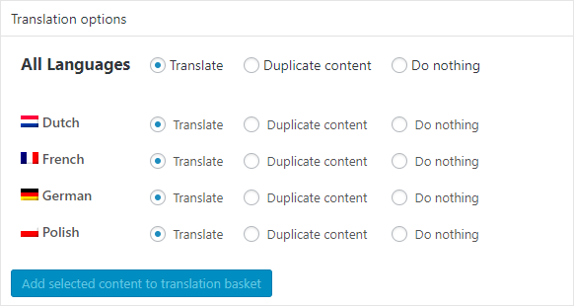

*Content translation options*

#### Translators

The Translators tab contains the list of available translators, an option to add a new translator, and available translation services. When you have installed and activated the XTM plugin, the xtm-wpml-connector will be visible. That is the default name for the XTM plugin. XTM Connect for WordPress only supports a WPML translator whose details are configured in the XTM plugin settings. For this reason, no other translator should be created on the Translators tab of the WPML plugin, as they will not be associated with the XTM plugin configuration.

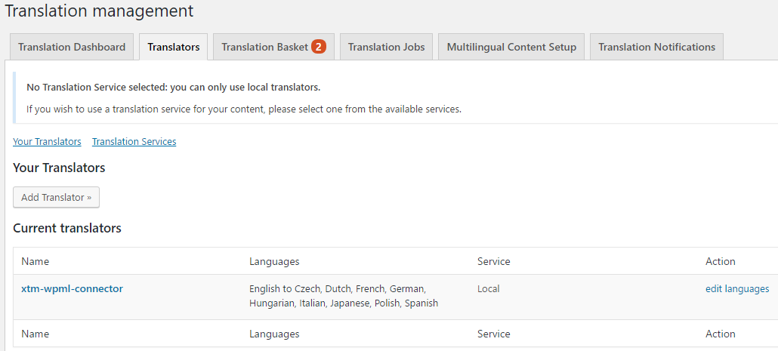

*WPML – Translators*

**Translator languages**

It is important to check if the languages configured for the xtm-wmpl-connector translator correspond to the content and translation languages specified for the WordPress website during the WPML setup.

**Translator name**

It is possible to modify the translator’s First Name, Last Name or Nickname to change how the connector is displayed on the list of translators. To do it just click the name of the connector and fill in the fields.

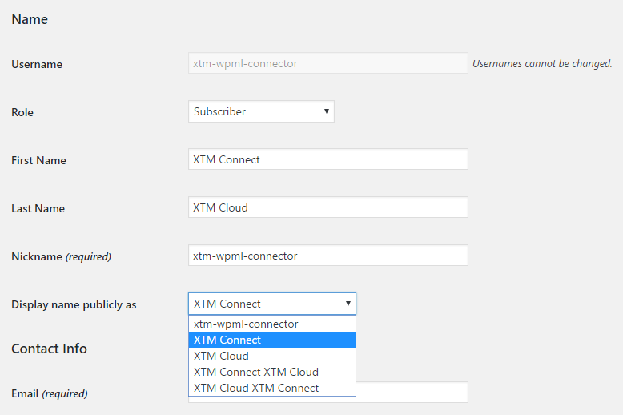

*Changing name displayed for the XTM Connect application*

#### Translation Basket

Jobs are added to the translation basket from the Translation Dashboard and String Translation WPML tabs. The number displayed on the tab next to Translation Basket indicates the number of items in the basket. Items listed in the translation basket can be removed or sent for translation. You can change the automatic batch name and select a translator for the items. To send content to XTM, select the XTM translator displayed as xtm-wpml-connector or another name if it was changed.

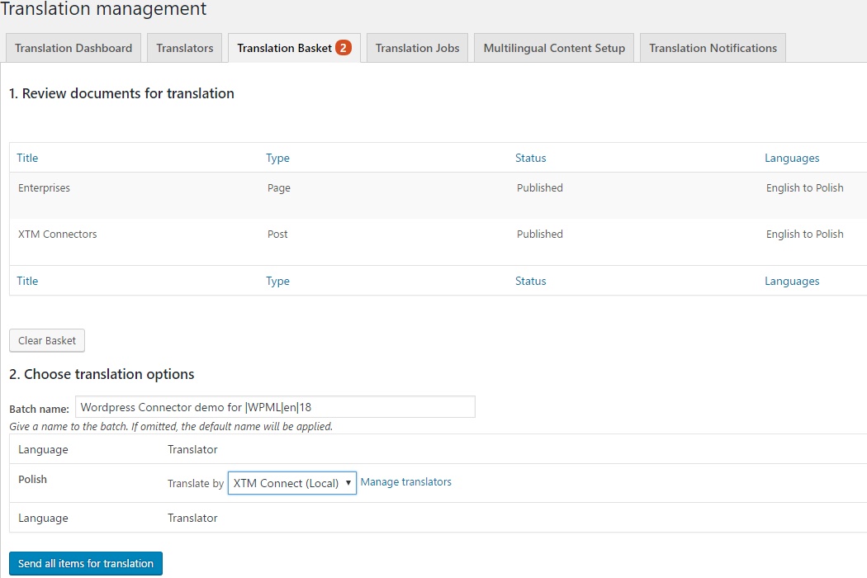

*WPML – Translation Basket*

#### Translation Jobs

The Translation Jobs tab lists jobs sent for translation from the translation basket. Translation jobs can be filtered by the translator assigned, by progress and by language combinations.

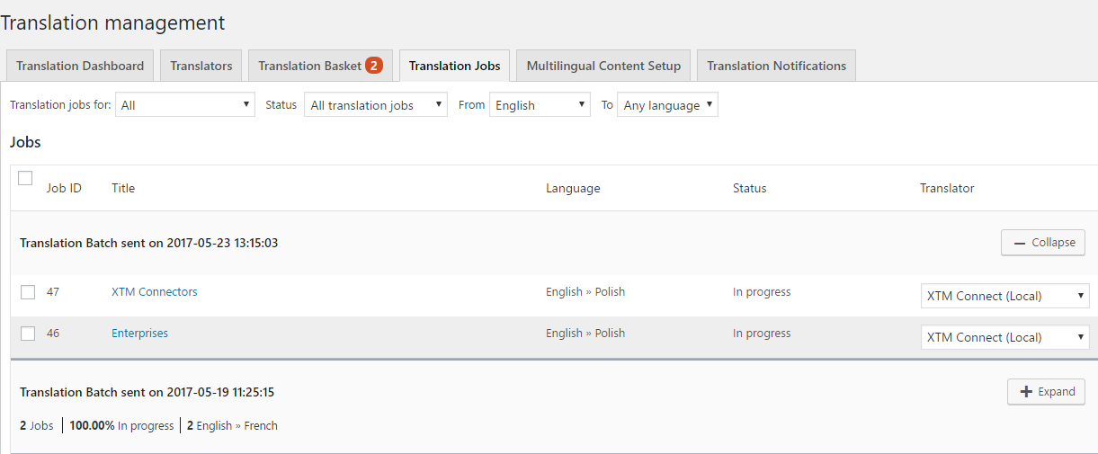

*WPML – Translation Jobs*

Translation jobs are displayed in batches that can be expanded or collapsed. In the expanded view, it is possible to change the translators assigned to translation job items or cancel them using the Cancel selected button at the bottom of the page.

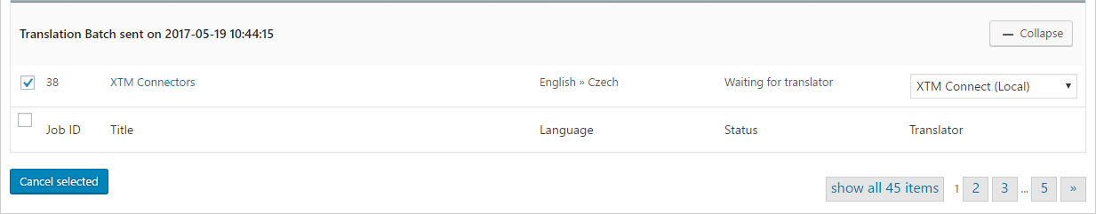

*Cancelling translation of an item in WPML*

### String Translation

The String Translation section of the WPML plugin contains strings. These strings can come from various website elements that include theme texts visible on the website as well as texts and labels built-in in the backend of the website. Strings can be filtered by translation progress and text domain. A search functionality is provided to look for strings in all resources.

Hardcoded strings are not taken for translation. In order to make a string translatable, you have to wrap it with _() or _e() function, for example:

<h2>Translation Management</h2>

<h2><?php _e('Translation Management','theme-text-domain'); ?></h2>

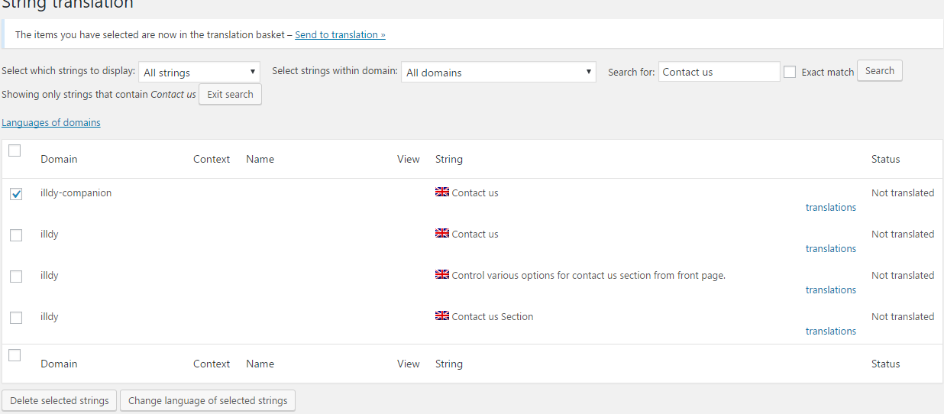

*WPML – String translation*

Strings selected on the list can be added to the translation basket, deleted or their language can be changed.

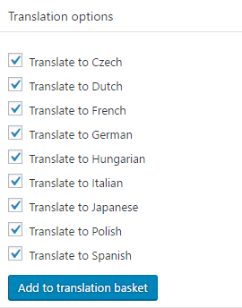

*String translation options*

**Track where string appear on the site**

When this option is enabled, you can check where specific strings are displayed on the website. To view a string on the website, click the View in page  icon in the View column.

**Auto register strings for translation**

WPML lists all text domains available on the website which confirms that all strings are detectable. Strings coming from text domains unintended for translation can be exclude to reduce false positive string search results.

**Translate texts in admin screens**

Sometimes the WPML incorrectly classifies a string and does not automatically display it in the string search results. In such cases, the string can be found using the Translate texts in the admin screens feature, provided that it is wrapped with the _() or _e() php function and contains a text domain. To find the string, click Translate texts in admin screens >>, expand the text domain of the string you are looking for. Then find it on the list, select it and click the Apply button at the bottom of the screen. If you are not sure what is the string’s text domain, you can check it in the website html code.



*Adding a string to the list of translatable strings using Translate texts in admin screens*

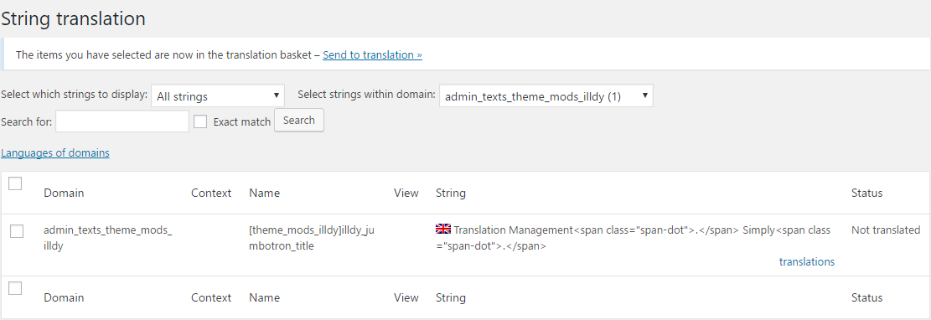

*Finding the string just added using Translate texts in admin screens*

More information about the WPML plugin is available here <https://wpml.org/documentation/>.

# XTM plugin

## XTM Settings – Configuration

The connection between WordPress and XTM is configured in the XTM plugin settings. The XTM plugin automatically verifies if the details entered are correct. When it cannot connect with the XTM account, a message will be displayed.

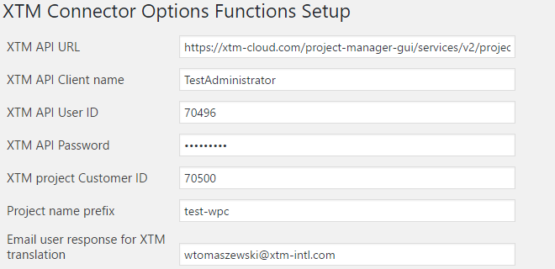

*XTM Connector configuration in XTM plugin’s settings*

* **XTM API URL** – URL of the SOAP service. In case of XTM Cloud, enter the following URL: [https://api.xtm-cloud.com//project-manager-gui/services/v2/projectmanager/XTMWebService?wsdl](https://www.xtm-cloud.com/project-manager-gui/services/v2/projectmanager/XTMWebService?wsdl)
* **XTM API Client name** – the name you enter in the Company field of the XTM login page.
* **XTM API User ID** – the project creator user ID. XTM recommends to create a new user specifically for XTM Connect so that it is simple to track XTM Connect activity separately from human actions. The XTM Connect user needs to have a Project Manager role. You can check the user ID in XTM on the User list (see picture *XTM User ID* below).
* **XTM API Password** – the password set for the project creator user. It is the normal password used by the user to log in to XTM
* **XTM project Customer ID** – the customer, for which you will be creating projects. You can check the customer ID in XTM on the Customer list similar to the way it is presented on picture *XTM User ID* below.
* **Project name prefix** – a prefix for projects automatically created by WordPress to differentiate them from projects created by Project Managers. Leave this field blank to disable the prefix.

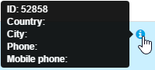

*XTM User ID*

* **Email user response for XTM translation** – the email address where notifications about the project will be sent.

### Language mappings

In this section, WordPress languages are mapped to XTM languages. It is important to verify that the language mappings are correct because XTM languages include variants of languages, such as English (UK), English (US) or French (France), French (Canada) or French (Switzerland). If a project is created in XTM using an incorrect language combination as a result of wrong language mapping, the customer’s translation memory may not be leveraged.

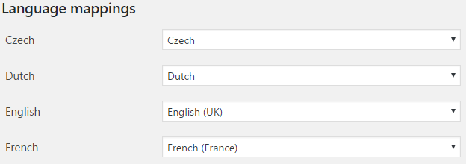

*XTM Settings – Language mappings*

### Default configuration

In this section, you can define the default settings and the behaviour of projects sent for translation using the XTM Connector.

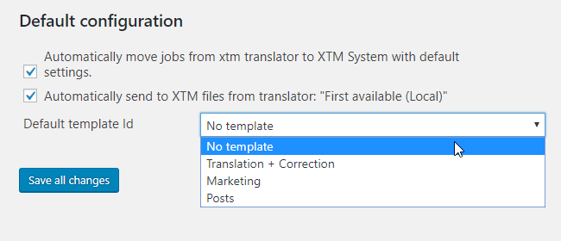

*XTM Settings – Default configuration*

**Automatically move jobs from xtm translator to XTM System with default settings.**

When this option is enabled, any files sent to the XTM plugin from WPML are automatically processed by the connector using the default settings and a project is automatically created in XTM without any human interaction.

**Automatically send files to XTM from translator: “First available (Local)”**

When this option is enabled, any files requested for translation from the translation basket are sent to the XTM plugin when the selected translator is First available (Local). This option streamlines the workflow by assigning XTM by default to all translation jobs.

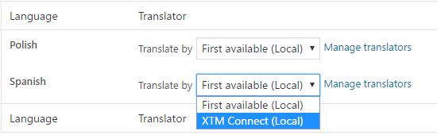

*First available (Local) translator in WPML Translation Basket*

**Default template Id**

The XTM plugin automatically detects any templates predefined for the customer in the XTM plugin settings. Customer predefined templates can be used to initiate a specific workflow with settings appropriate for the content at hand.

## WPML Job list

The WPML Job list section of the XTM plugin lists jobs received from the WPML translation basket. Jobs can be handled using bulk actions and one of the project modes described above. Bulk actions include the following options:

* Send to XTM without template
* Send to XTM with template:[name of the template]

The number of options depends on the number of templates defined for the customer.

Also, it is possible to filter jobs by the translation progress as well as the source and target language.

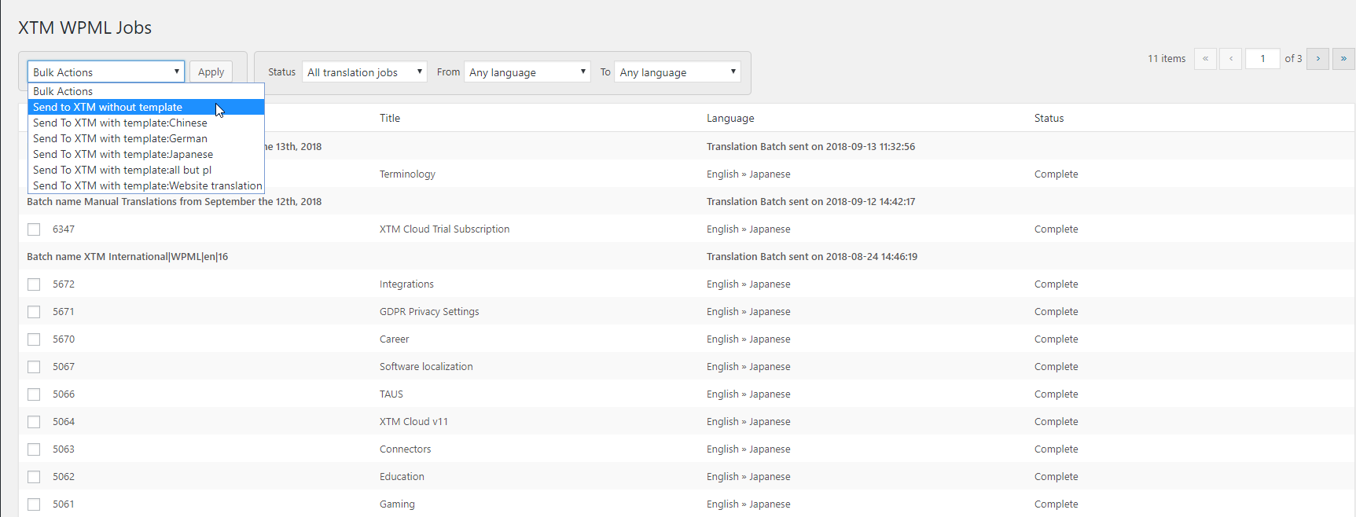

*WPML Job list*

## XTM Project list

The XTM Project list section of the XTM plugin lists projects already created in XTM. It provides the possibility to check the translation progress and cancel a project if need be. It is also possible to perform these actions on multiple projects in one go, or on projects filtered by the project creation mode, translation progress or source and target languages. You can click the XTM project id to open your XTM login website. To check the XTM status of multiple projects or to cancel them, you can use the bulk actions option.

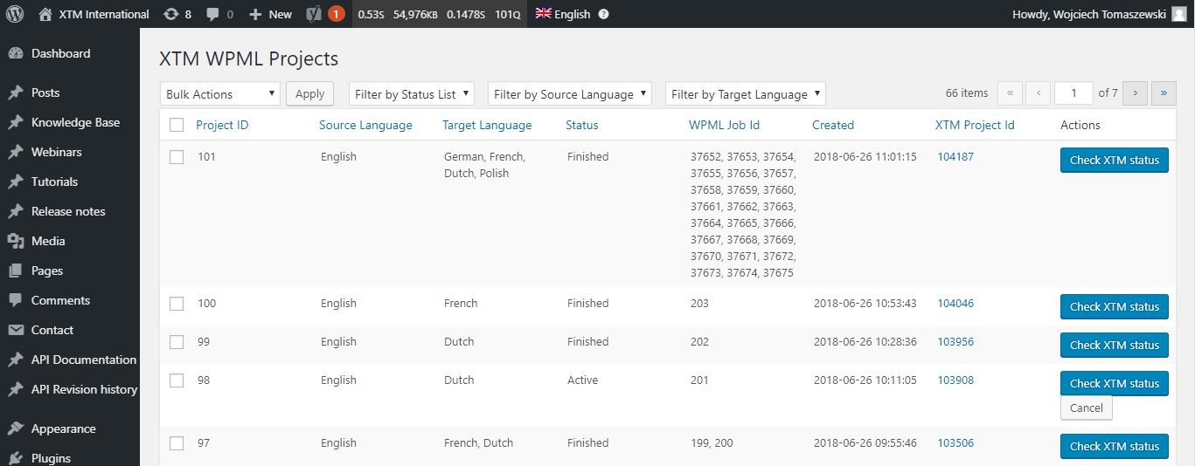

*XTM project list*